PRINCE2™- Project Initiation Documentation

Project Name: | Vision-based Active Lane Keep Assist
Date: | 7-12-2016 | Release: | Draft
Authors: | Anshuman Singh, Davide Occello, Raymond Wouters, Sharad Bhadgaonkar,
Owner: | TU/e
Client: | NXP, Gijs Dubbelman (TU/e)
Document Number: | 1

Note: This document is only valid on the day it was printed

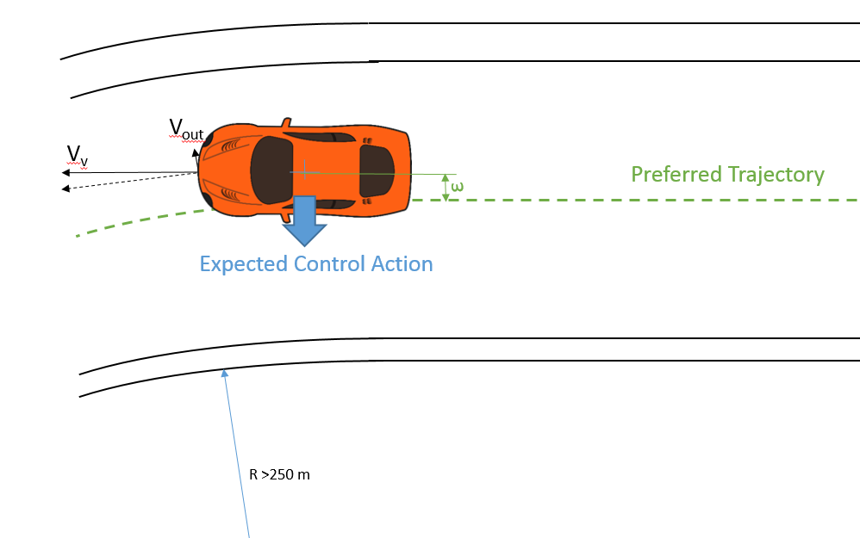

Revision History
Date of next revision:
Revision Date | Previous Revision Date | Summary of Changes | Changes Marked
07-12-2017 | n/a | First release | n/a

Approvals

This document requires the following approvals. A signed copy should be placed in the project files.
Name | Signature | Title | Date of Issue | Version
Dr. Peter Heuberger  Rameez, Gijs |  | Program Manager

Distribution

This document has been distributed to:
Name | Title | Date of Issue | Version

Overview

Purpose | The purpose of the Project Initiation Documentation is to define the project, in order to form the basis for its management and an assessment of its overall success. The Project Initiation Documentation gives the direction and scope of the project and (along with the Stage Plan) forms the ‘contract’ between the Project Manager and the Project Board.  The three primary uses of the Project Initiation Documentation are to:  - Ensure that the project has a sound basis before asking the Project Board to make any major commitment to the project  - Act as a base document against which the Project Board and Project Manager can assess progress, issues and ongoing viability questions  - Provide a single source of reference about the project so that people joining the ‘temporary organization’ can quickly and easily find out what the project is about, and how it is being managed.  The Project Initiation Documentation is a living product in that it should always reflect the current status, plans and controls of the project. Its component products will need to be updated and re-baselined, as necessary, at the end of each stage, to reflect the current status of its constituent parts.  The version of the Project Initiation Documentation that was used to gain authorization for the project is preserved as the basis against which performance will later be assessed when closing the project.
Contents | The Project Initiation Documentation should cover the following topics.  Project Definition 4  Project Approach 5  Business Case 6  Project Management Team Structure 6  Role Descriptions 6  Quality Management Strategy 7  Configuration Management Strategy 7  Risk Management Strategy 7  Communication Management Strategy 7  Project Plan 8  Project Controls 8  Tailoring of PRINCE2 8
Advice | The Project Initiation Documentation is derived from the Project Brief and discussions with user, business and supplier stakeholders for input on methods, standards and controls.  The Project Initiation Documentation could be a single document; an index for a collection of documents; a document with cross references to a number of other documents; a collection of information in a project management tool.  The following quality criteria should be observed:  - The Project Initiation Documentation correctly represents the project  - It shows a viable, achievable project that is in line with corporate strategy or overall programme needs  - The project management team structure is complete, with names and titles. All the roles have been considered and are backed up by agreed role descriptions. The relationships and lines of authority are clear. If necessary, the project management team structure says to whom the Project Board reports  - It clearly shows a control, reporting and direction regime that can be implemented, appropriate to the scale, risk and importance of the project to corporate or programme management  - The controls cover the needs of the Project Board, Project Manager and Team Managers and satisfy any delegated assurance requirements  - It is clear who will administer each control  - The project objectives, approach and strategies are consistent with the organization’s corporate social responsibility directive, and the project controls are adequate to ensure that the project remains compliant with such a directive  - Consideration has been given to the format of the Project Initiation Documentation. For small projects a single document is appropriate.  For large projects it is more appropriate for the Project Initiation Documentation to be a collection of stand-alone documents. The volatility of each element of the Project Initiation Documentation should be used to assess whether it should be stand-alone, e.g. elements that are likely to change frequently are best separated out.

Project Definition
The purpose of the project is to design and implement a vision based Active Lane Keep Assist system. A camera sensor must be used to detect and track ego lane boundaries and then an appropriate vehicle heading correction must be applied to keep the vehicle in ego lane.

Background
A major share of the automobile accidents on highways are caused when the driver is leaving his intended lane. This may happen due to lack of driver’s attention which can be caused by many factors such as fatigue, distraction, etc. The active lane keep assist system (ALKA) is a safety critical system aimed at decreasing the number of accidents caused during lane changes. The system detects an unintentional lane changes using vision based sensing and takes appropriate action to steer back the vehicle into the current lane. The system also warns the driver to make him aware of this potentially hazardous situation ahead. ALKA system is a safety critical system and therefore it must comply with the automotive functional safety standards of ISO26262.

Project objectives
The objectives of the project are:

- To design a vision based Active Lane Keep Assist system, meant for lateral control only.
- To implement the designed system on NXP Bluebox and Speedgoat in a Toyota Prius..
- To ensure that the designed system complies with the Automotive Functional Safety Standards (ISO 26262) and the Euro NCAP for lane support systems.

Desired outcomes

- Literature Review
  - Euro NCAP (versions)
  - ISO 26262 (Strict requirements)
- Presentation of the Literature Review (12/01/2017)
  - Max 40 minutes, including Questions
- Safety Requirements Document (13/01/2017)( Max 10 pages)
  - HARA
  - Safety Goals
  - Functional Safety Concept
- Design Document (27/01/2017)
  - High-level design (10 pages)
  - Using CAFCR (no special preference, but we know this)
  - Planning
- Implementation Phase Deliverables (28/03/2017)
  - Updated design and manual (15 pages)
  - Demo and presentation (40 minutes)

Project scope and exclusions

Constraints and assumptions

The user(s) and any other known interested parties

Interfaces

Project Approach
The project has been divided to three phases. The three phases are listed below.

Phase 1: Functional Safety
- Functional Safety
  - What are the Euro NCAP requirements for ALKA
  - What are the risk levels (ASIL)
  - How does that translate to functional safety requirements ISO 26262 in terms of
    - system architecture
    - Hard- / software

Phase 2: Design
- Design
  - Components
  - Interfaces
  - What is available when
  - What is not
- Parallel workshops

Phase 3: Implementation
- Implementation
  - Integration of existing components
  - Development of new components
  - Unit-testing of components
  - System testing
  - Documenting

The focus of this PID is the first phase of the project i.e. Functional Safety. The deliverables for this phase are:

- Document describing ASIL requirements, NCAP requirements, and to which extent next-generation in-vehicle computation solutions meet these requirements.
- CAFCR project planning for the case-study.

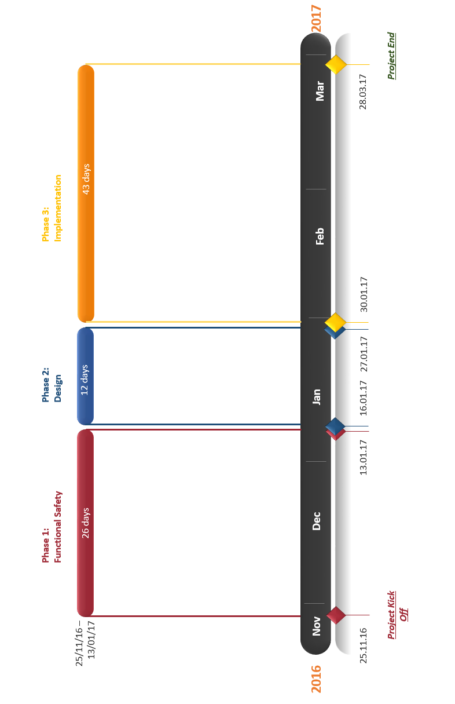

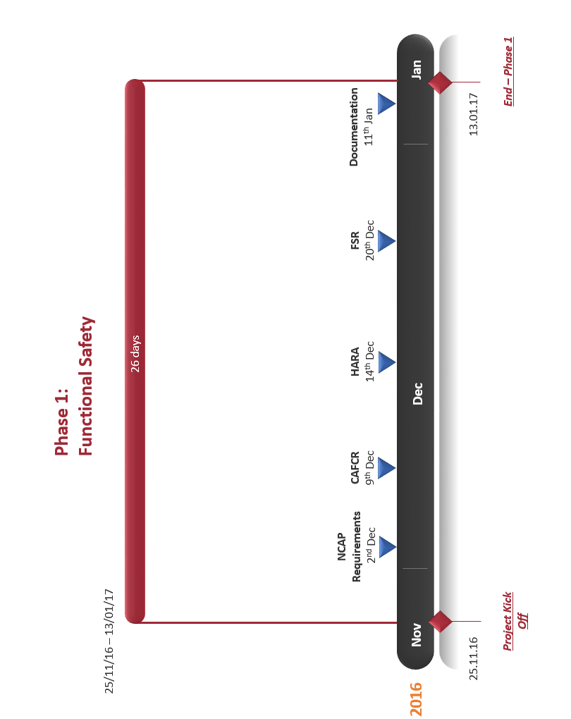

Business Case
(Describing the justification for the project based on estimated costs, risks and benefits)

Project Management Team Structure
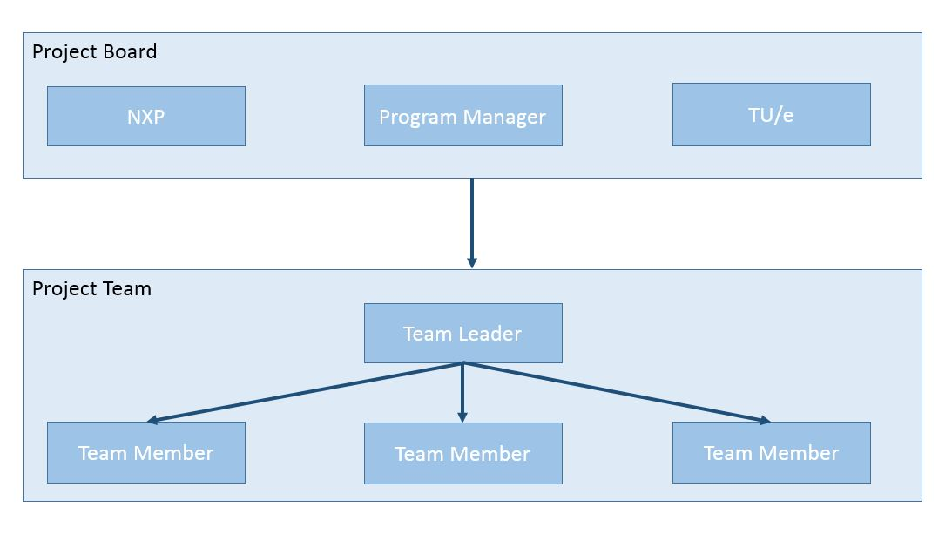

Role Descriptions
Project Board

Name | Position | Role
Rameez Ismail | Pdeng, ASD | NXP Customer
Peter Heuberger | Program Director | Educational Affairs
Gijs Dubbelman | TU/e | Sensing Algorithms
Jos den Ouden | TU/e | Toyota Prius Components
Arash Kabash | TU/e | Functional Safety

Project Team

Name | Position | Role
Anshuman | Pdeng, ASD | Team Member
Davide | Pdeng, ASD | Team Leader
Raymond | Pdeng, ASD | Team Member
Sharad | Pdeng, ASD | Team Member

Quality Management Strategy
(Describing the quality techniques and standards to be applied, and the responsibilities for achieving the required quality levels)

Evaluation of the deliverables,
Process for managing the quality
Things we define as Acceptable/Good quality

Configuration Management Strategy
(Describing how and by whom the project’s products will be controlled and protected)

Project Documentation – Dropbox and GitHub

Risk Management Strategy
The risk management strategy developed for the project has four steps listed below.

Risk Identification: Identifying the risks within the project. The risk will be classified into two categories i.e. long term and short term.

Risk Prevention: Mitigation strategies for both long term and short term risks will be developed during weekly planning meetings.

Risk Management: Contingency plans will be developed for risks which cannot be prevented.

Risk Monitoring: Risk Analysis document will be prepared for identified risks and the related mitigation actions.

Communication Management Strategy
The communication plan has been fixed for the project. The responsibility of communication with the Project Board is through the Team Leader. The team leader is responsible for setting up meeting with the members of the boards for any purpose of communication. Within the team, the communication is through regular project meetings. A weekly meeting is scheduled on Monday for updating the Project Plan.

Project Plan
(Describing how and when the project’s objectives are to be achieved, by showing the major products, activities and resources required on the project. It provides a baseline against which to monitor the project’s progress stage by stage)

The important milestones for the first phase of the project are:

Project Controls
(Summarizing the project-level controls such as stage boundaries, agreed tolerances, monitoring and reporting)

Tailoring of PRINCE2
(A summary of how PRINCE2 will be tailored for the project.)

